# 

|  |  |  |  |
| --- | --- | --- | --- |
| **Date** | **Theme** | **Table of content** | **Modification** |
| 29/09/2020 | Stage capacity | 2.k.a) p.7 | Upgrade capacity up to 12 and 7 people ++ |
| 1/10/2020 | Public Capacity | B. Capacities p.11-13 | Sales Plan in Box-Office |
|  |  |  |  |
|  |  |  |  |
|  |  |  |  |
|  |  |  |  |
|  |  |  |  |
|  |  |  |  |
|  |  |  |  |
|  |  |  |  |
|  |  |  |  |
|  |  |  |  |
|  |  |  |  |
|  |  |  |  |
|  |  |  |  |
|  |  |  |  |
|  |  |  |  |
|  |  |  |  |
|  |  |  |  |
|  |  |  |  |
|  |  |  |  |
|  |  |  |  |
|  |  |  |  |
|  |  |  |  |
|  |  |  |  |

# Centre for Fine Arts in Brussels –

# M Hall and Studio

Operation based on the terms and conditions of the MD of 22 August 2020

**Summary of the main measures:**

* **wearing of a mask compulsory anywhere in the Centre for Fine Arts building;**
* **respect for social distancing of 150 cm;**
* **regular hand washing with hand sanitiser gel or soap and water;**
* **circulation flow plan for the backstage area and public areas;**
* **no public cloakrooms;**
* **no intervals;**
* **no bars;**
* **maximum performance time < 2 hours;**
* **room plan with social distancing measures and staggered rows.**

## Health rules

### General provisions

* All the directives and recommendations issued by the Government in the context of the fight against COVID-19 must be respected and incorporated into the general provisions applied to BOZAR.
* Anyone who shows symptoms or feels ill must stay at home or go home immediately and report this to the HR department for BOZAR staff or to the production manager at BOZAR for external staff.
* For the BOZAR and production teams: a temporary confinement room has been set up on the ground floor of the 13 Baron Horta building. Where necessary, it will be used as a waiting area if symptoms appear. The room is equipped with a non-contact digital thermometer and masks for the person accompanying the patient while they are waiting to leave. The space must be well ventilated. Any BOZAR or external staff member showing symptoms must immediately return home or remain in this room until a relative or the emergency services can collect them.
* The presence of third parties in all BOZAR areas not dedicated to specific production is strictly forbidden. No one who does not have a BOZAR employment contract is allowed access to the administrative areas.
* The preparatory meetings will be held exclusively by videoconference (Teams or Zoom).
* The number of people present at the Centre for Fine Arts will be reduced to the minimum strictly necessary for each production.

### Distancing

1. The necessary measures must be taken to ensure compliance with social distancing rules, in particular maintaining a distance of 1.5 metres between each person; including during artistic performances. This provision is the "principal and priority preventive measure".
2. A maximum measure will be defined and displayed for each space. This measure must be respected at all times.
3. Break times must be organised and staggered to avoid crowds.
4. Smokers must ensure that they respect social distancing instructions and do not block the movement areas at the building entrances and exits.

### Protection

1. BOZAR will provide its staff with personal protective equipment. Each external service provider must ensure that they do the same (mandatory masks - gloves, goggles, etc. depending on the specific needs of the activity).
2. **Wearing a mask is mandatory throughout the building.**
3. With regard to HVAC (temperature regulation in the hall): following recommendations by GEES experts, the air conditioning will use COMPLETELY fresh, outside air.

### Hygiene

1. Hand sanitiser gel is available at the entrances and in the backstage area of the halls. **Everyone must wash their hands on entering the Centre for Fine Arts**, and then regularly use the hand sanitiser gel provided or soap and water.
2. Where possible, doors must be kept open to limit contact with handles, provided that this does not prevent access being regulated (and does not contravene general fire safety provisions such as fire doors not fitted with an automatic closing device).
3. Communal areas (door handles, toilets, handrails, etc.) will be cleaned and disinfected on a regular basis by BOZAR Cleaning maintenance teams.
4. Pedal bins are distributed throughout the building for used protective equipment.

### Control and compliance

1. A "Covid Pool" contact group has been set up and is responsible for monitoring compliance with these provisions, among other things. The technicians at the Centre for Fine Arts can contact them if they have any questions or suggestions for improving the health provisions.
2. However, each external team leader remains responsible for ensuring that their team respect all these measures while at the Centre for Fine Arts.
3. If the orchestra, troupe, artist, technical service provider, events office or any other external party has defined its own health protocol, the strictest conditions will apply to its teams. Only the BOZAR health protocol will apply to BOZAR staff, unless there has been prior consultation with the production prevention adviser or manager.
4. In the event of repeated failure or refusal to comply with the procedures, the Covid Pool will contact the manager of the department concerned (internal producer or Planning Dept) with a view to resolving the problem. They will inform the Standing Committee of this. The activity will be stopped if the problem cannot be solved.

## Organisation

### Access for external teams

1. The complete list of external persons who will work in the Centre for Fine Arts will be sent at least 48 working hours in advance.
2. Access and exit are exclusively through the service entrance on Rue Terarken and visiting the security office is mandatory, on both the arrival and the departure of the teams.
3. All members of external teams entering the Centre for Fine Arts must be identified by a coloured bracelet which will be issued at the security office. This identity bracelet must be worn throughout the time the external teams are present. Only artists are exempt from wearing this bracelet - but not from having one - and must produce it on request.

### Deliveries

1. Deliveries for the M Hall and the Studio must arrive exclusively via the unloading area on Rue des Sols. No exceptions via 23 Rue Ravenstein or the Concierge Service will be allowed.
2. Everyone must ensure that they comply with the health recommendations for hand hygiene before and after handling equipment. Hand sanitiser gel will be made available in all delivery and backstage areas for this purpose.

### Instruments

1. Each orchestra or ensemble is responsible for its own instruments, their accessories and for disinfection.
2. BOZAR will be responsible for its piano. The stage manager will disinfect the keyboards after any intervention by the tuner. The keyboard cover will be locked immediately after tuning and between rehearsals or between the rehearsal and the concert.

### Technical equipment

1. All BOZAR mobile technical equipment will be disinfected by the EPA teams after each use (e.g. microphones, consoles, microphone stands). The same applies to the equipment rented by BOZAR.
2. Frequently touched fixed technical equipment (fixed consoles, switch blocks, touch screens, etc.) will be disinfected by the EPA teams between each session.

### Lifts and goods lifts

1. The use of lifts and goods lifts is reserved exclusively for the transport of objects which cannot be carried via the stairs (any object which cannot be carried by one person because of its volume or weight [> 18 kg] is considered to be unsuitable for carriage via the stairs) and for persons with reduced mobility. Any other use is prohibited.
2. The capacity indicated for each lift and goods lift must be respected at all times.

### Assembly and dismantling

1. Technical interventions will take place in compliance with distancing rules.
2. The capacity indicated for each room will be respected at all times.

### Breaks

1. For the time being, the break area for productions in the Chamber Music Hall and the Studio is the Terarken Room 3; masks may be removed during the break in order to eat.
2. Distancing rules and other barrier measures will apply.
3. The distancing of the furniture (tables and chairs) will not be changed, except in the case of prior consultation and agreement between the Covid Pool manager and the production manager or their prevention adviser.
4. Breaks and meals will be staggered to limit the number of people in the area.
5. A specific disinfection kit will be available for the drink dispensers provided for artists and technical teams.
6. Disposable cups must be thrown into the pedal bins provided.
7. Artists and technicians must dispose of their bottles, cups and other disposable dishes in the pedal bins located in the backstage area.

### Reception of artists and use of dressing rooms

1. A proposal for the use of the dressing rooms must be sent at least 48 working hours before production.
2. The Centre for Fine Arts teams will clean and disinfect the dressing rooms before they are occupied.
3. A disinfection kit (consisting of a hydroalcoholic spray and a cloth) will be available in each dressing room so that artists can disinfect the surfaces as needed.
4. A one-way circulation flow plan is on display in the dressing rooms and must be respected.

1. The maximum capacity allowed in these areas will be displayed and must be respected at all times.
2. The capacity of the dressing rooms is as follows:





the dressing rooms located on the upper level of the Studio are temporarily inaccessible.

The capacity of the Backstage areas is as follows:





i.e. a theoretical capacity of five persons for the M Hall and four persons for the Studio.

The Backstage areas can also accommodate nine people in the M Hall and seven people in the Studio (including five artists for the M Hall and four artists for the Studio).

The maximum capacity authorised for the podiums is as follows:

* + M Hall: eight artists and three technicians
  + Studio: four artists and two technicians

1. A plastic bag will be provided in each dressing room and the artist occupying the room must ensure that all the towels provided are placed in it before their departure so that they can be taken to the laundry with no risk of contaminating the BOZAR staff.
2. The presence of caterers or cooks is not allowed. Artists may only receive catering deliveries. No drinks for artists or production teams will be allowed in the dressing rooms and backstage areas.
3. If the requirements of the performances mean that it is not possible to comply with point f), stage capacities, BOZAR will decline all liability by means of a document signed in advance (between the parties) and issued by the BOZAR legal service.

### Use of toilet blocks

1. Toilets S2 and S3 are reserved for productions in the M Hall and the toilet block on the dressing room floor for Studio productions. For this toilet block and given its narrow access, a system giving priority to people going down (leaving the toilets) will be introduced to manage the circulation flow in the staircase.
2. The maximum capacity will be displayed and must be respected. Distancing rules must be respected. The production manager will ensure that these rules are applied, particularly during breaks for groups whose composition exceeds the capacity of the toilet block.
3. The Centre for Fine Arts cleaning teams will regularly disinfect this toilet block.

### Circulation in the backstage area

1. All the backstage areas of the M Hall have a total capacity of nine people (including five artists).
2. All the backstage areas of the Studio have a total capacity of seven people (including four artists).
3. Artists must maintain social distancing rules when they enter the stage.
4. A pedal bin will be provided at each entrance for artists to dispose of their used masks just before they enter the stage.

### Provisions for musicians

1. The following capacities (maximum) of each scene are applicable:





1. These provisions have been formulated by the Charité University Hospital of Berlin and adopted by many orchestras, such as the Berlin Philharmonic, DSO, Berliner Staatskapelle, and the Konzerthaus Orchestra. Pending legal provisions or recommendations from the National Security Council, BOZAR intends to comply with these scientific recommendations:

* Spacing of seats for string instruments - 1.5 m.
* Spacing of seats for wind instruments - 2 m. Draining of liquids and cleaning of instruments with disposable wipes (to be disposed of in closed bins) or cloths (to be cleaned). Additional Plexiglas protection must be provided for brass instruments.
* Spacing of seats for percussion instruments - 1.5 m. It is strongly recommended that the sharing of instruments and/or accessories be avoided.
* Spacing of seats for harps and keyboard instruments - 1.5 m.
* Distance between the conductor and the musicians of at least 2 m for the rehearsal and at least 1.5 m for the concert.
* A general physical distance of 1.5 metres must be maintained at all times inside and outside the concert hall.
* The wearing of masks is mandatory in enclosed spaces outside the concert hall. The set is the only place where the wearing of masks is not required.

### Succession of activities and simultaneous use of the M Hall, Studio and HLB

1. Sufficient time for the cleaning and disinfection of the halls will be scheduled between activities and included in the schedule of activities. This time will be determined in consultation with Mr Rudi Anneessens.
2. The halls may be used simultaneously, but only under the following conditions:
   * minimum 60 minutes free time between the start of the performances, and
   * minimum 30 minutes free time between the end of the performances

in the M Hall, the Studio and the HLB Hall. This provision makes it possible to maintain the public circulation flows without people passing each other or gathering together. If this provision cannot be guaranteed, the simultaneous use of the halls is prohibited and certain activities cannot be scheduled.

As an illustration, here is the programme for a typical evening with the use of the HLB Hall, the M Hall and the Studio.



*Exits from the Studio, the M Hall and the HLB Hall in the event of simultaneous use according to the example programme*

## Welcoming the public

## BOZAR Tickets

The theoretical maximum capacity of the box office is seven members of the public and two members of BOZAR staff, with three service or queueing spots.

Only electronic payments are accepted.

A series of health measures has also been put in place:

* + hand sanitiser gel for the public when they enter the BO
  + wearing of a mask mandatory for staff and customers
  + disinfection kit available (consisting of a hydroalcoholic spray and a cloth)

for Bancontact terminals (no strips)

* + anti-spray plexiglass at each point of sale
  + floor markings inside and outside (cf. plan) one-way circulation
  + ventilation of the premises, preferably open doors
  + distanced queueing system with floor markings
  + no seating
  + signs with reminders of the health measures

## Welcoming the public and directing them to the theatres - Organising the exit of the public - Programmes - Cloakrooms - Bars - Intervals - Duration of the Performances

### Hygiene

Before and after each performance and/or between two consecutive performances, the hall will be cleaned and all surfaces that are frequently touched and likely to be contaminated will be disinfected, both in the hall and in all accessible ancillary areas (toilets, counters, etc.).

### Welcoming the public

The doors will be opened well in advance of the scheduled start time of the performance to allow the optimal distribution of the public in the reception areas. The public will be asked to avoid arriving at the last-minute.

The Centre for Fine Arts will have a strategic stock of face-masks at the entrance to the building for people who have forgotten, lost or damaged their mask. Where applicable, they will be distributed to the public at the counter specifically designated for this purpose.

### COVID-19 communication

A specific communication campaign has been prepared and introduced with the Communication Department of the Centre for Fine Arts. It consists of different notices, displayed throughout the route taken by the public, from the building entrance to inside the toilet blocks. They remind the public of the barrier measures and cleaning methods. They also state the room capacities.

### Temporary confinement room (Public)

For the public: a temporary confinement room has been created in the sick room in the HLB Hall. Where necessary, it will be used as a waiting area if symptoms appear. The room is equipped with a non-contact digital thermometer and masks for the person accompanying the patient while they are waiting to leave. The space must be well ventilated. Any member of the public showing symptoms must immediately return home or remain in this room until a relative or the emergency services can collect them.

### Capacities

The Ministerial Decree of 22 August 2020 limits capacities to a maximum of 200 people indoors with compliance with social distancing. The capacity of the Chamber Music Hall will therefore be limited to this maximum number, in accordance with the following room plan:

The capacity of the Chamber Music Hall will be limited to 128 spectators (in bubbles of two people, and in bubbles of one) in accordance with the following room plans:

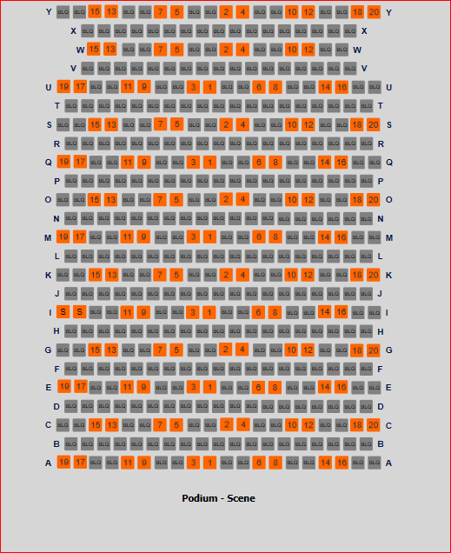

|  |  |
| --- | --- |
| Bubbels 2 | 128 |
|  |  |
| Servitudes | -2 |
| Patron | -4 |
| VIP | -6 |
| Technique en salle |  |
|  |  |
|  |  |
|  | **116** |

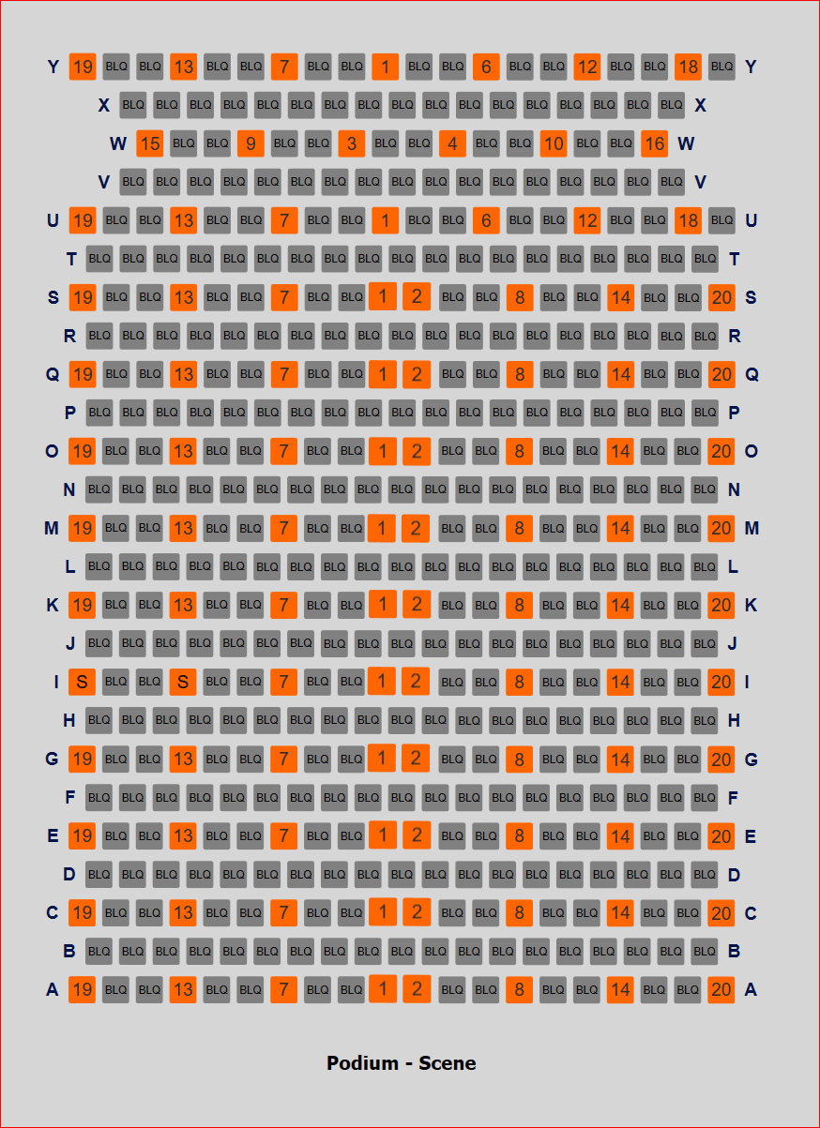

|  |  |
| --- | --- |
| Bubles 1 | 108 |
| Bubles 2 | 20 |
|  |  |
|  | 128 |
|  |  |
| Servitudes | -2 |
| Patrons | -6 |
| Press | -2 |
| VIP | -8 |
|  |  |
|  | **110** |

The capacity of the Studio will be limited to 60 spectators, in accordance with the following room plan:

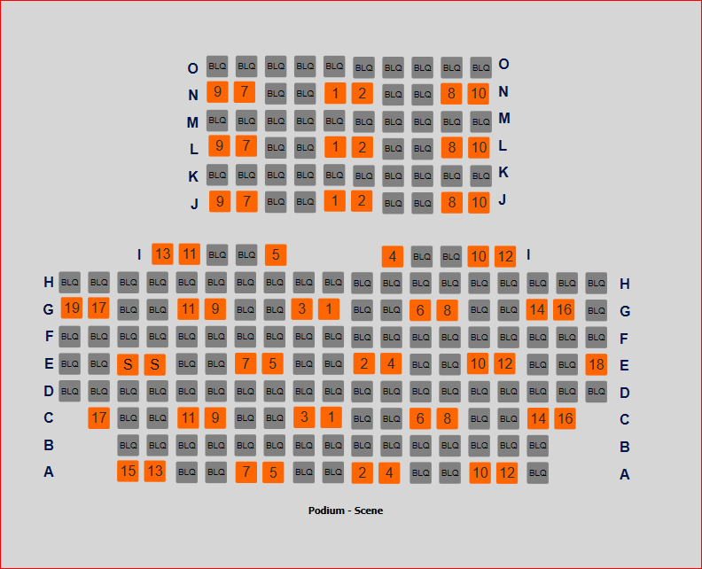

|  |  |
| --- | --- |
| Bubles 1 | 4 |
| Bubles 2 | 56 |
|  |  |
| TOTAL | 60 |
|  |  |
| Servitudes | -2 |
| Patron | -2 |
| Press | -1 |
| VIP | -4 |
|  |  |
|  | **51** |

### Direction to halls

The public will be requested to arrive at the 23 Ravenstein Street entrance. The public will take the following route from the entrance to the PBA to the hall:

*Level 0 (Rue Ravenstein)*

*Level -1 (Smoking room)*

In the event of a sudden influx, spectators will be asked to wait outside and the Bas Smets structure will be used to manage the overflow and organise the orderly entrance of the public.

To organise arrivals, the producers and sponsors of concerts and shows will be asked to send tickets out digitally.

To organise the VIP Desks, the producers and sponsors of concerts and shows will be asked to send VIP tickets out digitally.

The VIP welcome desks will be arranged in accordance with the modalities defined by the welcome services, which will depend on the organisation of the performances and concerts on the day. Anti-spray plexiglass will be provided at the reception desks.

Tickets can be booked/sold on the basis of the room plan, taking account of the maximum room capacities (128 seats for the M Hall and 60 seats for the Studio). The seats will be numbered.

**The public is required to wear a mask in the hall and in surrounding area before, during and after the concert.**

### Organisation of public exits

The departure of the public will be staggered (For the M Hall: Rows Y to S, then Rows Q to K, and lastly Rows I to A - For the Studio: odd side first, then even side). Exception for persons with reduced mobility (PRM), who will be asked to leave first.

*Exits from the M Hall*

*Exits from the Studio*

*Exits from the Studio, the M Hall and the HLB Hall in the event of simultaneous use according to the example programme*

### Programmes

There will be no sale or distribution of programmes for the shows. Programmes will be available to download, as part of the paperless policy of the Centre for Fine Arts.

### Cloakrooms

The cloakrooms will remain closed to avoid queues and crowds. The public will be asked not to arrive with bulky bags or suitcases.

In view of the physical distancing provisions in force in the hall, access to the halls will be allowed with a jacket and/or umbrella, on a temporary basis.

### Bars

The bars will remain closed before, during and after the performances until further notice, to avoid crowds.

### Intervals

All concerts and shows will be held without intervals to avoid crowds.

### Duration of performances

In view of these constraints, no performance will last longer than two hours.

### Access to toilets

Access to the Smoking room toilets will be possible only before the performances. The Terarken Room 2 toilets will be the only toilets accessible when leaving the halls.

The social distancing measures must be respected in the toilet blocks. One in two urinals will be inaccessible.